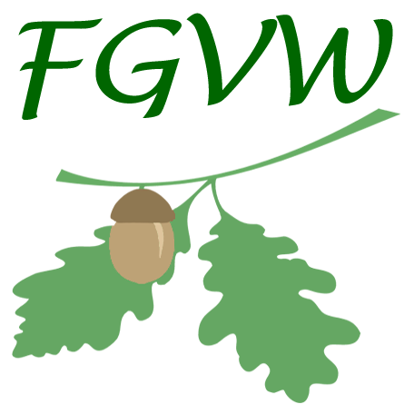 | Friends of Gledhow Valley Woods  Membership Application Form

The purchase of a meadow in 2016 required FGVW to become a registered charity. Following on from this, paid membership has been introduced for supporters wishing to vote at AGMs, and stand as a trustee.

Please Note: Membership is not needed to attend Action Mornings, Core Group Meetings or AGMs, or to receive FGVW Update e-mails.

Membership is only needed if you want to vote at AGMs.
Membership is £5 per year or £50 for life membership.

To become a voting FGVW Member, please complete the form and return with payment to:

Adrian Coltman
FGVW Membership Secretary
5 Gledhow Park Crescent
Leeds LS7 4JY

Cheques should be made out to Friends of Gledhow Valley Woods. Cash should not be sent through the post but may be used if the application is hand-delivered or handed directly to the Membership Secretary.

Name: .............................................................................................................................................

Address: .............................................................................................................................................

.............................................................................................................................................

.............................................................................................................................................

Postcode: ........................................... Phone: ..................................................

E-mail: .............................................................................................................................................
(used to inform you of the AGM and other FGVW events)

Signed: .......................................................... Dated: ...................................................

Your details will not be shared with any other organisation.
Charity registration number: 1169599 Web: www.fgvw.co.uk E-mail: info@fgvw.co.uk

